COINS-EUR-Sol Invictus-Aurelian-270-275 CE

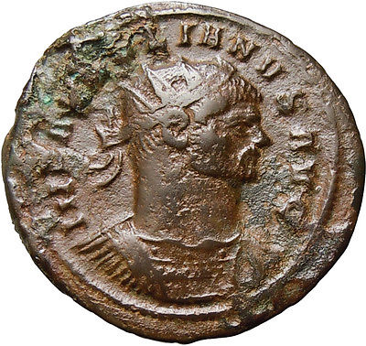 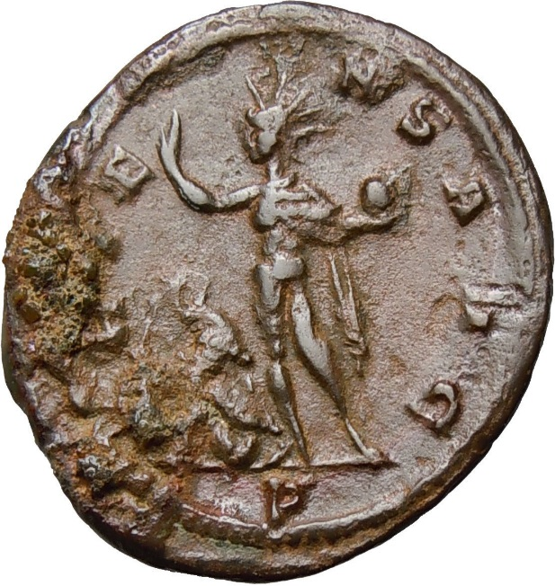

[**Aurelian AE Antoninianus Oriens Sol Globe Authentic Ancient Roman Coin Rare**](http://www.ebay.com/itm/261935739142)

**Aurelian - Roman Emperor: 270-275 AD. - AE Antoninianus**  
Obverse: IMP AVRELIANVS AVG, radiate, cuirassed bust right    
Reverse: ORIENS AVG, Sol standing right, head turned left, holding globe and raising right hand, captive to left, P in exergue   
Weight: 3.2 g   
Diameter: 24 mm

Reference : Sear5 11564v